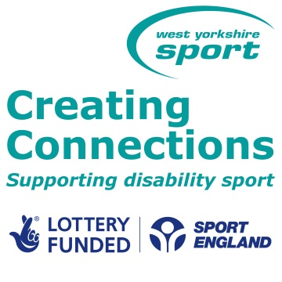  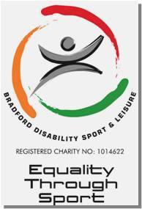 | BDSL Sport and Physical Activity Recommendation Form
 | Participant details
 | Name: |  | D.O.B:
Address:

Postcode:
Telephone number:

Email:
 | Criteria
Recommending Agent | - Recommendations are available for all disabled people
Name:

Job Title:

Contact Tel:

Email Address:

Organisation / Address:

Please tick this box if you would like to be informed of the participants progress:
☐
 | Impairment details
 | Please tick the appropriate box(es) and provide further details to allow us to accurately recommend activity:
 | Physical (Ambulant) ☐ | Physical (Manual Chair) ☐ |  | Physical (Powerchair) ☐
 | Visual ☐ | Learning ☐ |  | Mental Illness ☐
 | Communication ☐ | Hearing ☐ |  | Other ☐
 | Other questions that will help identify suitable sport / physical activity
Is the participant able to travel independently? Yes ☐ No ☐

How far would the participant be willing to travel for activity? Up to:
2 miles ☐ 5 miles ☐ 10 miles ☐ 15 miles ☐ Above 15 miles ☐
 | Please detail any sport / exercise interests or current participation activities:
 | Other information that may be useful when finding a suitable sport / exercise club, including any sport the participant would not want to take part in:
The details on this form will be used to contact the participant with information about sport opportunities.
I agree to my personal details being stored by Bradford Disability Sport and Leisure (BDSL) and passed on to organisations working in partnership with BDSL such as West Yorkshire Sport, local authorities and National Governing Bodies of Sport.
Signed by participant________________________ Print name: Date:
Please send the completed form to Bradford Disability Sport and Leisure
Tel: 01274437093 ¦ Website: www.bradforddisabilitysports.co.uk ¦ Email: andrew.lane@wydsport.co.uk

BDSL, Shipley Town Hall, Bradford, BD18 3EJ. Registered charity number: 1014622

